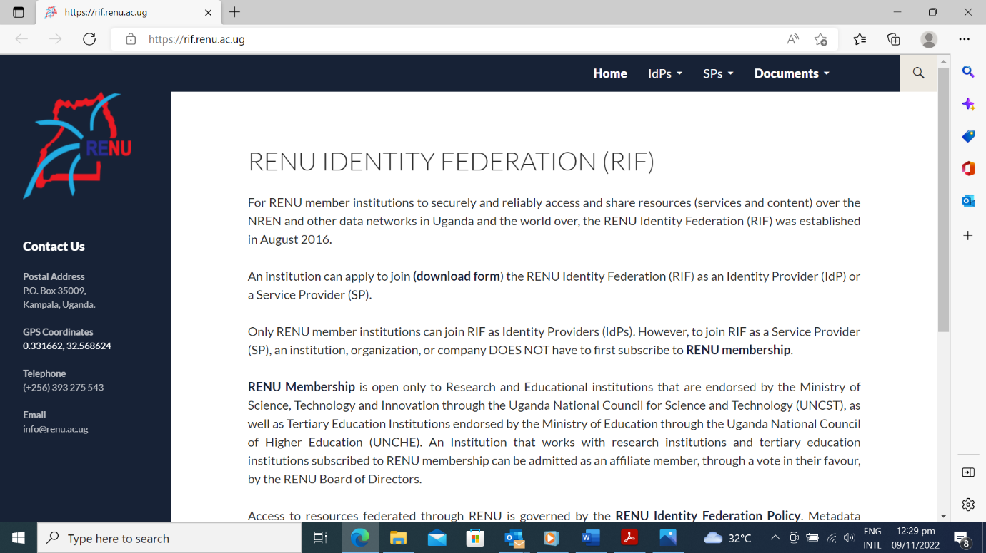

GARNET IDENTITY FEDERATION (GIF)

For GARNET member institutions to access and share resources (services and content) over the GARNET Network and other data networks in the region and globally, the GARNET Identity Federation (GIF) was established in October 2022 securely and reliably.

To join the GARNET Identity Federation, an institution is required to apply (**download and fill-in form**) either as an Identity Provider (IdP) or a Service Provider (SP)

Only GARNET member institutions can join GIF as Identity Providers (IdPs). However, to join GIF as a Service Provider (SP), an institution, organization, or company DOES NOT have to first subscribe to **GARNET** [**membership**](https://renu.ac.ug/index.php/about-us/membership).

[**GARNET Membership**](https://renu.ac.ug/index.php/about-us/membership) is open only to Research and Educational institutions that are accredited by the Ghana Tertiary Education Commission (GTEC) or operate under the auspices of the Ministry of Environment Science, Technology, and Innovation (MESTI). Institutions which conduct research and education as part of their mandate such as research Hospitals and Libraries may subscribe to GARNET membership and can be admitted on approval by the GARNET Board of Directors.

Access to resources federated through GARNET is governed by the [**GARNET Identity Federation Policy**](http://rif.renu.ac.ug/docs/rifp.pdf). Metadata registration in GIF is governed by the GIF **Metadata Registration Practice Statement.**

**eduroam**

eduroam is an Authentication and Authorization Infrastructure (AAI) based on RADIUS or RadSEC. The Technology Profile for eduroam under the GARNET Identity Federation can be accessed **here** *(use hyperlink)* [*https://gif.garnet.edu.gh/docs/*](https://gif.garnet.edu.gh/docs/)

**SAML WebSSO**

The SAML V2.0 Web Browser SSO Profile defines a standard that enables Identity Providers and relying parties to create and use web Single Sign On services using SAML Requirements. The SAML WebSSO Technology Profile for the GARNET Identity Federation (GIF) can be accessed [**here**](http://rif.renu.ac.ug/docs/RIF-SAML-WebSSO-Technology-Profile.pdf)**.**[*https://gif.garnet.edu.gh/docs/*](https://gif.garnet.edu.gh/docs/)

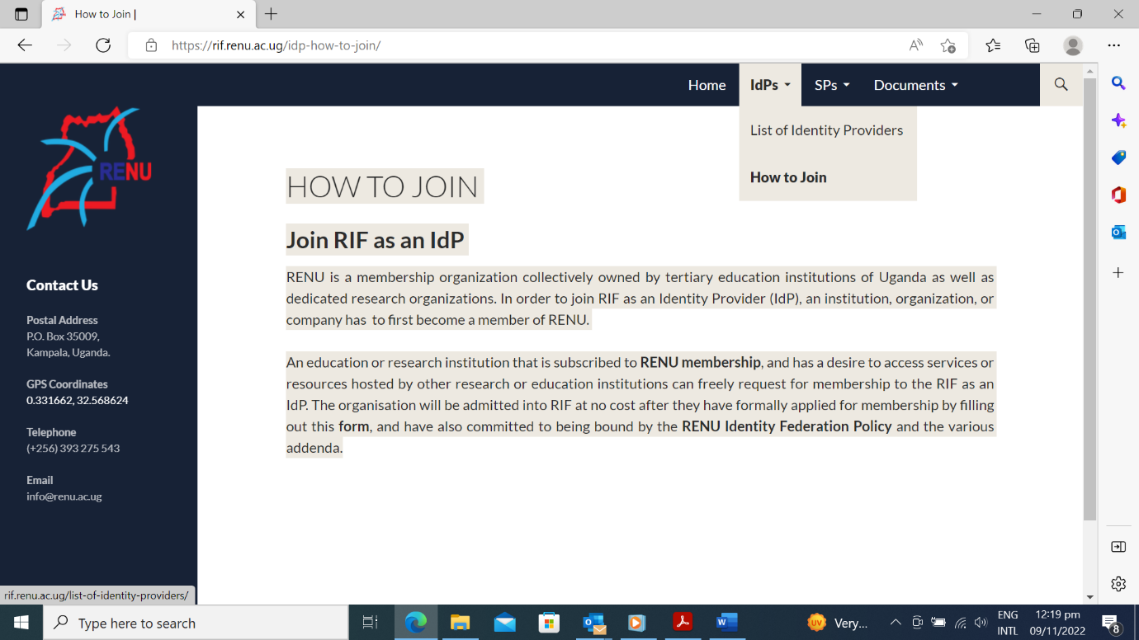

LIST OF IDENTITY PROVIDERS

Identity Providers (IdPs) are members of the GARNET Identity Federation that provide the required infrastructure for the authentication of users.

**Identity Providers under GIF**

* University of Ghana (UG)
* Kwame Nkrumah University of Science and Technology (KNUST)
* Ghanaian Academic and Research Network (GARNET)
  + **Type:** Identity Provider
  + **Organisation:** GARNET
  + **Contact Info:** [Support](mailto:systems@renu.ac.ug) or [Technical](mailto:technical@renu.ac.ug)
* Ashesi University (AU)

HOW TO JOIN

**Join GIF as an IdP**

GARNET is a not-for-profit membership organization collectively owned by its members. To join the Federation as an Identity Provider (IdP), an institution has to first become a member of GARNET.

An institution that is subscribed to **GARNET membership** and has a desire to access services or resources hosted by other research or education institutions can freely request for membership to the GIF as an IdP. The organisation will be admitted into GIF at no cost after a formal application for membership is submitted by filling out this **form** and making a commitment to be bound by the **GARNET Identity Federation Policy** and the various addenda.

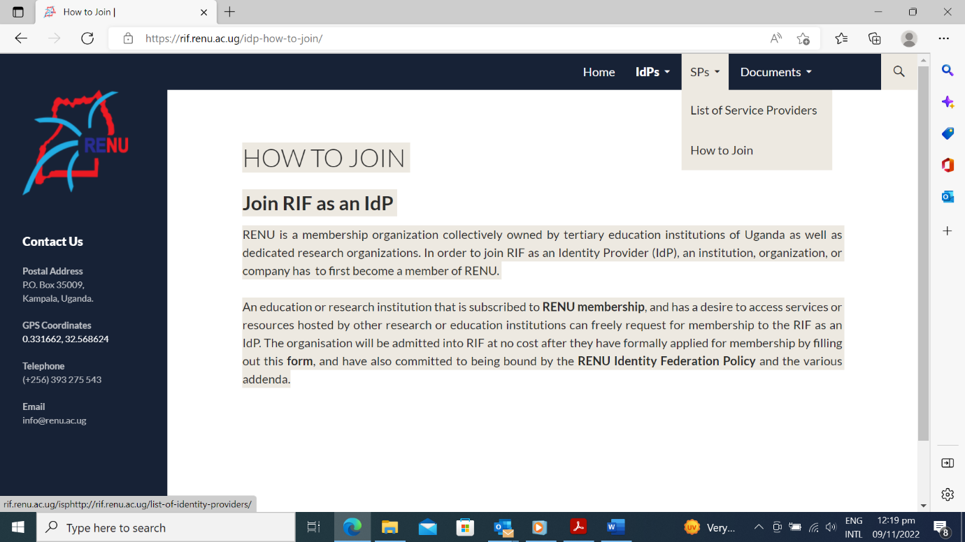

LIST OF SERVICE PROVIDERS

Service Providers (SPs) are members of the GARNET Identity Federation that provide services to other federation members or allow access to resources that they own or manage.

**Service Providers under GIF**

* GARNET | Zoom
* GARNET | eduroam

eduroam (education roaming) is an international roaming service for users in research institutions. It provides researchers, teachers and students easy and secure network access when visiting an institution other than their own. Authentication of users is performed by their home institution, using the same credentials as when they access the network locally, while authorization to access the Internet and possibly other resources is handled by the visited institution. Users do not have to pay for using eduroam.

* GARNET | Tertiary Mobile Data Bundle
* CARLIGH | Library Resources

HOW TO JOIN

**Join GIF as an SP**

GARNET is a not-for-profit membership organization collectively owned by its members. To join GIF as a Service Provider (SP), an institution DOES NOT have to first become a member of GARNET.

An education or research institution that is subscribed to **GARNET membership** and has a desire to share resources as a Service Provider, can freely request for membership to the GIF, and can be admitted into GIF at no cost. The organisation must formally apply for membership by filling out this application **form** and must also commit to being bound by the **GARNET Identity Federation Policy** and the various addenda.

Organisations that are not subscribed to GARNET membership and have a desire to join the GIF as a SP only, can join under non-member terms. Please contact the GARNET Secretariat for more details.

